**Diary Management System**

**Advanced Database Design**

**CS-603-B**

##### TechME



Sacred Heart University

School of Computer Science & Engineering The Jack Welch College of Business & Technology

Submitted To Dr. Reza Sadeghi

Spring 2022

CS-603-B Project Progress Report Phase #3 TechME

**TechME**

# Project Phase 03 for

# Diary Management System (DMS)

### Team Members

1. Kiera Cutri cutrik@mail.sacredheart.edu
2. Ankush Chaudhari chaudharia@mail.sacredheart.edu

### Roles of Team Members

1. Kiera Cutri (Team Head)
2. Ankush Chaudhari (Team Member)

2

CS-603-B Project Progress Report Phase #3 TechME

## Table of Contents

Team Member Introduction 4

Project Summary 5

Purpose

Scope

Motivation

Literature Summary

Pros and Cons

Entities and Keys 6

Entity-Relationship (ER) to Enhanced Entity-Relationship (EER) Model

SQL Code Desc.

Entities, Attributes, and Keys 7

SQL Code 8,9,10

Models and Figures 11

Entity-Relationship (ER) Model

Enhanced Entity-Relationship (EER) Model

Citations 12

**Table of Figures**

Fig. 1 - Entity-Relationship (ER) Model 11  
Fig. 2 - Enhanced Entity-Relationship (EER) Model 11

3

**Team Member Introduction**

**Kiera Mariah Cutri**

SHU ID Number: 0813395

SHU Email: [cutrik@mail.sacredheart.edu](mailto:cutrik@mail.sacredheart.edu)

Kiera Cutri is a current Computer Science graduate student at Sacred Heart University; they have previous experience with C++, C#, Java, and Python. Kiera has previously worked at the Sacred Heart Factory as a level one technician for 3 years where she gained experience with troubleshooting various software issues; she has also performed various repairs and upgrades to her laptop.

I met Ankush after the first Advanced Database course and we conversed about interests, backgrounds, and hobbies. After finding common ground for interests, I thought that he would be a good partner for the project, he reached out to me first regarding group work. The team leader was decided through a discussion of responsibilities and through deciding who would prefer to take the role.

**Ankush Chaudhari**

SHU ID Number: 0882634

SHU Email: [chaudharia@mail.sacredheart.edu](mailto:chaudharia@mail.sacredheart.edu)

I am Ankush Chaudhari. Currently, I am a graduate student at Sacred Heart University. I have completed my Undergrad in Electronics and Telecommunication Engineering. After I completed my degree, I worked for MNC as an implementation consultant for 1.6 years. My role was to handle ERP systems, Client relations Project Management, Vendor Management, provide clients hands on training on the system, and design and integrate the system according to client requirements. I am very passionate about my work role. my team had received an extra mile reward for completing the project before the deadline.

It was the first day of my Database Management class. I was seated in the first row. Kiera was seated towards my right. We had little conversation regarding the software installation and some doubts. After class we had a brief conversation regarding our backgrounds. Kiera completed her undergraduate in gaming, she also told me about her interest in various programming languages which she has known. On that point I decided that Kiera is a perfect team partner and head, so I approached her and now we are a team.

4

**Purpose**

The purpose of the Diary Management System (DMS) is to aid staff members within a department to collaborate and organize in a school setting. This system allows faculty members to update their activity details within a diary that is accessible to relevant users. Permitted users will have access to the activity of specific events that have been logged within the system. This proposed system aims to minimize the time burden imposed on faculty members by allowing users to search for a colleague's log within their diary. The Head of Department (HOD) will be able to view each faculty member's diary logs.

**Scope**

TechME aims to produce an application that will provide greater ease for users by allowing users to effortlessly search and find records that pertain to other colleagues. This system provides users with an advanced and secure way to store documents than can be accessed by higher ups within a department.

**Motivation**

These days, everything is stored within databases. Our staff continues to use more traditional logging methods when recording work information. To make the most out of current technology, we are creating a work diary management system which will allow faculty members to upgrade their work from traditional logging techniques to databases.

**Literature Survey**

Keeping logs to maintain work records daily allows faculty members to keep track of their work in their department. Each faculty member keeps and maintains a traditional diary which stores logs of their workday. Faculty members input various information relevant to their workday such as attendance, course number, semester taught, comments for the class, and content covered during lecture. The diary logs are later reviewed by the Department Head at the end of the day. Within our college, every faculty member keeps and maintains a work diary to enter logs of their workday daily. By maintaining a work diary, it allows faculty members to detail their workday and keep a log that would be available to other coworkers within their department. By having a diary system in place, it allows others to know the daily routines of faculty members and allows for easier assignment based on availability.

We were able to gauge an idea of how this system would work based on an online example of a diary management system on sourcecodester.com [2].

**Pros and Cons**

When considering the Diary Management System. We considered potential positives and negatives that would attribute to the system. The primary positives of the system would be that it would provide an accurate timeline of events and permit for easier scheduling of employees. The system would be able to support multiple team members at once and would allow coworkers to hold each other accountable for each other for specific actions preformed. The primary potential negatives we came across for this project would be a decrease in teamwork among members, large data size which use large pieces of software which would occupy multiple megabytes of diskspace, there could be an annual recurrent maintenance cost, and an ethical concern for privacy.

For more information regarding this project, please refer to the following github repository: <https://github.com/cutrik/CS603-FinalProject>

5

**Entities and Keys**

When selecting entities for our project, we examined how a university or college works and attempted to mimic how they operate within the database. We began by looking at the direct relationships among members of an institution; we noticed that there were individuals who worked for the institution which fell under faculty or staff members. We noticed that students interacted with both faculty and staff. Since faculty and staff members played a vital role in the Diary management System, we included them in our entity list.

We observed that the institution utilized multiple buildings and classrooms which members of the institution interacted with. When we looked to how faculty members use the building, we included aspects which were being used. Building name, classroom location, department, and the subject which the faculty member taught were all aspects of the institution which would allow for more detailed diary entries. Faculty members have information that pertain to themselves and to other aspects of the institution such as scheduling and teaching. Faculty members belong to different departments based on their specialized subjects which impacted what they would teach to students.

We noticed that the faculty members schedules aligned with what students would take based on what the faculty member would teach; we thought it important to include aspects of the student and faculty interaction in our database using student class status and student schedule. We noticed that students typically had declared one major but would still take a variety of subjects for their schedule. With each subject that a student would take, each class would occur at different times and different days for varied durations.

**ER to EER Model**

After considering what all our entities would be for the Diary Management System (DMS), we broke down what attributes would apart of each entity. We viewed each entity and determined which ones were strong and which ones would be weak; afterwards, we listed what type of relationship each of our entities would have with each other such as many to many, one to one, and one to many. After determining the relationships between entities, we transferred this into an ER Model. Once the ER Model was created, we transferred the information into an EER Model by adding datatypes to each attribute. We kept the names of entities and attributes across models.

**SQL Code**

When writing the code for the database we referred to w3schools.com [5] and guru99.com [4] for how to write and format primary keys and foreign keys. The image above links to a copy of the SQL code for the Diary Management System.

6

**All Entities, Attributes, and Keys**

|  |  |
| --- | --- |
| **Faculty**  StaffID PK  Title  Status  Tenured  **Staff**  StaffID PK  StaffFirstName  StaffLastName  StaffPhoneNumber  Salary  DateHired  Position  **Departments**  DepartmentID PK  DeptName  DeptChair FK  **FacultyClasses**  StaffID CPK  ClassID CPK  SubjectID CPK  **Subjects**  SubjectID PK  CategoryID FK  SubjectCode  SubjectName  SubjectPreReq  SubjectDescription  **Classes**  ClassID PK  SubjectID FK  ClassRoomID FK  Credits  StartDate  StartTime  Duration  MondaySchedule  TuesdaySchedule  WednesdaySchedule  ThursdaySchedule  FridaySchedule  SaturdaySchedule | **Classrooms**  ClassRoomID PK  BuildingCode FK  PhoneAvailable  **Building**  BuildingCode PK  BuildingName  NumberOfFloors  ElevatorAccess  SiteParkingAvailable  **StudentSchedule**  ClassID CPK  StudentID CPK  ClassStatus FK  Grade  **Students**  StudentID PK  StudentFirstName  StudentLastName  StudentPhoneNumber  StudentGPA  StudentMajor  **SubjectsHaveStudents**  SubjectID  StudentID  MajorID  **StudentClassStatus**  CategoryID PK  CategoryDescription  **Majors**  MajorID PK  Major  **Categories**  CategoryID PK  CategoryDescription  DepartmentID |

**7**

**SQL Code**

When creating our database, we observed how most systems work in a school setting. When looking to things like if a faculty member were tenured, if a phone would be available, or if an elevator would be available in the building, we decided to use a single character to indicate if these things were available by having a yes (‘y’) value or a no (‘n’) value. Information such as titles, names, positions, and schedule we were unsure how many characters the user would input so we made sure to make these attributes variable characters. For attributes such as date hired, phone number, salary, and credits we knew that these values would be integer values and have allotted a value for how many digits would be input by the user; for example, phone numbers generally take the format of ‘(xxx) xxx-xxxx’ in the United States, so we have allowed for 10 integer values to be input. The grade point average (GPA) uses a float value based on how averages are calculated on a 4-point scale, at a school such as Sacred Heart University, GPA values appear in the format 0.000, based on the number of digits we have set the value to allow 4 digits. For attributes such as subject code, subject name, and other class identifying attributes, we will only be using integer values; unlike some school districts which use a mixture of characters and integers, we will identify by using certain hundreds or thousands of values to differentiate between courses, subjects…etc.

create table if not exists faculty(staffID int(8),

title varchar(15),

status varchar(15),

tenured char(1),

CONSTRAINT pk_faculty_SID PRIMARY KEY(staffID));

create table if not exists staff(staffID int(8),

staffFirstName varchar(15),

staffLastName varchar(15),

staffPhoneNumber int(10),

salary int(7),

dateHired int(8),

position varchar(15),

CONSTRAINT pk_staff_SID PRIMARY KEY(staffID));

create table if not exists departments(departmentID int(8),

deptName varchar(45),

deptChair varchar(30),

CONSTRAINT pk_departments_SID PRIMARY KEY(departmentID));

create table if not exists falcultyClasses(staffID int(8),

classID int(8),

subjectID int(8));

create table if not exists subjects(subjectID int(8),

categoryID int(8),

subjectCode varchar(15),

subjectName varchar(15),

subjectPreReq varchar(15),

subjectDescription varchar(45),

CONSTRAINT pk_subjects_SID PRIMARY KEY(subjectID),

CONSTRAINT fk_categoryID FOREIGN KEY (categoryID) REFERENCES categories(categoryID));

create table if not exists categories(categoryID int(8),

categoryDescription varchar(45), 8

departmentID int(8),

CONSTRAINT pk_categories_SID PRIMARY KEY(categoryID));

create table if not exists classes(classID int(8),

subjectID int(8),

classRoomID int(8),

credits int(1),

startDate int(6),

startTime int(4),

duration int(6),

mondaySchedule varchar(45),

tuesdayScheudle varchar(45),

wednesdaySchedule varchar(45),

thursdaySchedule varchar(45),

fridaySchedule varchar(45),

saturdaySchedule varchar(45),

CONSTRAINT pk_class_SID PRIMARY KEY(classID),

CONSTRAINT fk_subjectID FOREIGN KEY (subjectID) REFERENCES categories(subjectID),

CONSTRAINT fk_classRoomID FOREIGN KEY (classRoomID) REFERENCES categories(classRoomID));

create table if not exists classrooms(classRoomID int(8),

buildingCode varchar(8),

phoneAvailable char(1),

CONSTRAINT pk_classrooms_SID PRIMARY KEY(classRoomID),

CONSTRAINT fk_buildingCode FOREIGN KEY (buildingCode) REFERENCES categories(buildingCode));

create table if not exists building(buildingCode int(8),

buildingName varchar(45),

numberOfFloors int(2),

elevatorAccess char(1),

siteParkingAvailable char(1),

CONSTRAINT pk_building_SID PRIMARY KEY(buildingCode));

create table if not exists studentSchedule(classID int(8),

studentID int(8),

classStatus varchar(15),

grade float(4),

CONSTRAINT fk_classStatus FOREIGN KEY (classStatus) REFERENCES categories(classStatus)

);

create table if not exists students(studentID int(8),

studentFirstName varchar(15),

studentLastName varchar(15),

studentPhoneNumber int(10),

studentGPA float(4),

studentMajor varchar(45),

CONSTRAINT pk_students_SID PRIMARY KEY(studentID));

create table if not exists subjectsHaveStudents(subjectID int(8),

studentID int(8),

majorID int(8)); 9

create table if not exists studentClassStatus(categoryID int(8),

categoryDescription varchar(45),

CONSTRAINT pk_studentClassStatus_SID PRIMARY KEY(categoryID));

create table if not exists majors(majorID int(8),

Major varchar(45),

CONSTRAINT pk_majors_SID PRIMARY KEY(majorID));

10

**Models and Figures**

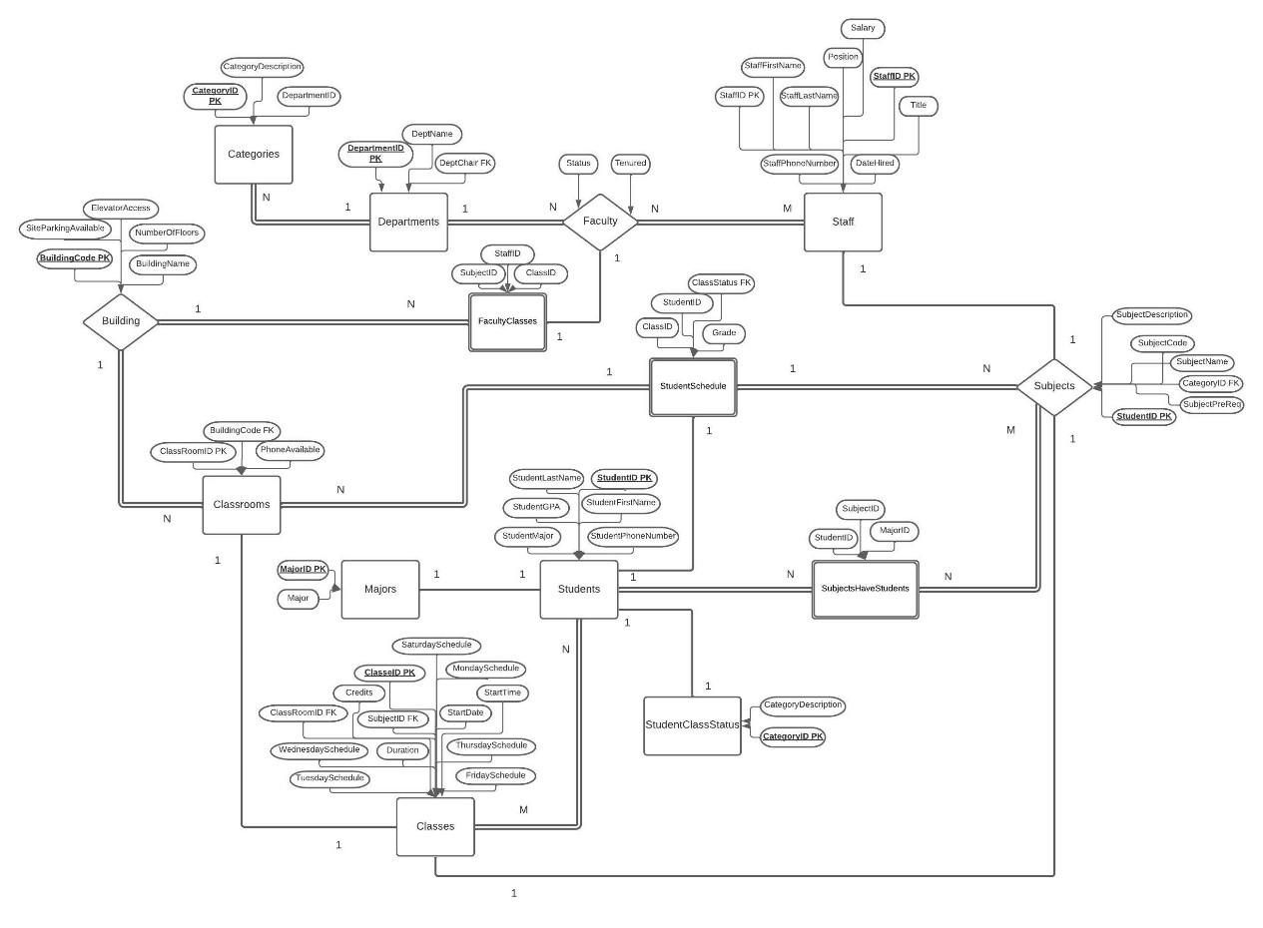

Figure 1: ER Model

Created in Lucidchart at [www.lucidchart.com](http://www.lucidchart.com) [3]

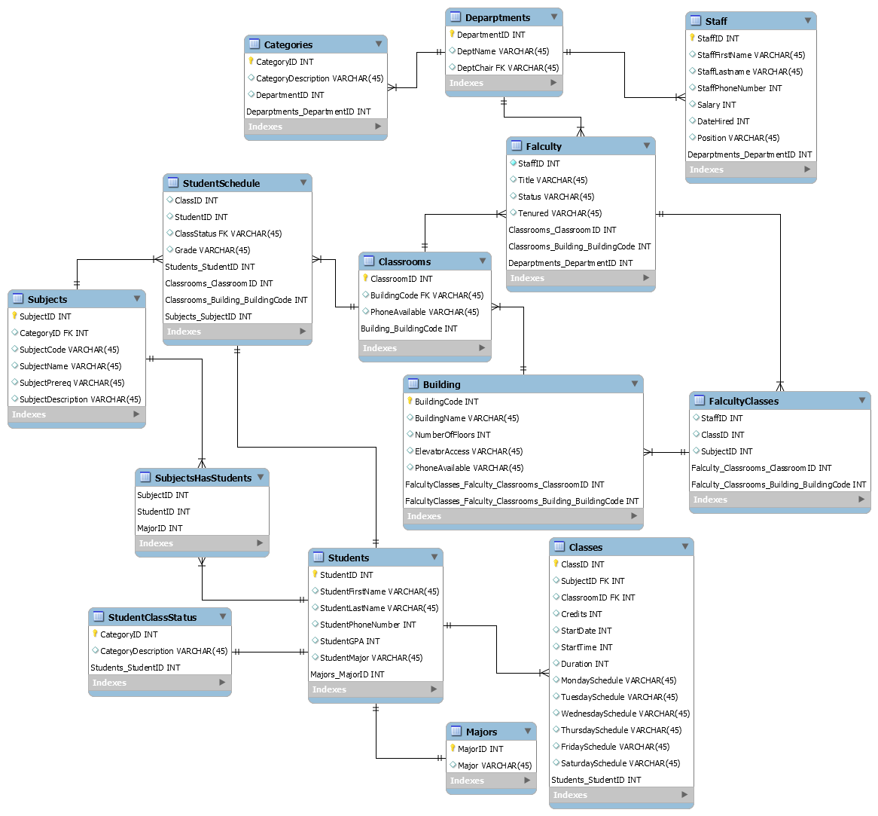[1]

Figure 2: EER Model

11

**Citations**

1. Viescas, John L. “School Scheduling Modify Database Page 883.” *SQL Queries for Mere Mortals: A Hands-on Guide to Data Manipulation in SQL*, Pearson Technology Group Canada, 2018.
2. elinet. “Elinet.” *Free Source Code, Projects & Tutorials*, 11 Sept. 2014, https://www.sourcecodester.com/php/7943/online-diary-management-system.html.
3. W, Megan. “Urgent! -- Cite LudicChart – Lucidchart.” *Lucidchart*, 20 Sept. 2018, https://lucidchart.zendesk.com/hc/en-us/community/posts/360018227346-URGENT-Cite-LudicChart.
4. Peterson, Richard. “SQL Primary Key: How to Create & Add to Existing Table.” *Guru99*, 29 Jan. 2022, https://www.guru99.com/sql-server-primary-key.html.
5. “SQL FOREIGN KEY Constraint.” *SQL Foreign Key Constraint*, https://www.w3schools.com/sql/sql_foreignkey.asp.

12